# PE20 – DOM Manipulation

**Code Examples**

**Add a click event to #link1**

htmlElement = webBrowser1.Document.GetElementById("link1");

htmlElement.Click += new HtmlElementEventHandler(LinkHtmlElement_Click);

**Change all text to a shade of blue**

htmlElement = webBrowser1.Document.Body;

htmlElement.Style = "color: #0000a4;";

**Append a new footer element to the end of the page**

htmlElement = webBrowser1.Document.CreateElement("footer");

htmlElement.InnerText = "This is my newly created footer!";

htmlElement.SetAttribute("id", "footer");

htmlElement.SetAttribute("class", "footerClass");

htmlElement.SetAttribute("title", "Footer is Here");

webBrowser1.Document.Body.AppendChild(htmlElement);

**Replace the HTML of an element and remove the click event delegate**

// Replace the link with a paragraph element

htmlElement.OuterHtml = "<p>Stop clicking me!</p>";

htmlElement.Click -= LinkHtmlElement_Click;

**Insert a new anchor element inside a new paragraph**

htmlElement = webBrowser.Document.CreateElement("p");

htmlElement.InnerHtml = "<a href=\"http://www.rit.edu\">RIT</a>";

**Insert a new anchor element relative to #footer**

htmlElement = webBrowser1.Document.CreateElement("a");

htmlElement.InnerText = "RIT";

htmlElement.SetAttribute("href", "http://www.rit.edu");

HtmlElement footerElement = webBrowser1.Document.GetElementById("footer");

// possible options are:

// BeforeBegin: insert new element before this element

// AfterBegin: insert new element within and at the start of this element

// BeforeEnd: insert new element within and at the end of this element

// AfterEnd: insert new element after this element

footerElement.InsertAdjacentElement(HtmlElementInsertionOrientation.AfterEnd, htmlElement);

**Get an array of elements by the tag definition**

HtmlElementCollection htmlElementCollection =

webBrowser.Document.GetElementsByTagName("p");

foreach( HtmlElement htmlElement1 in htmlElementCollection )

{

}

1. Download the example_html.zip attached to this assignment in myCourses. Unzip the example.html to a folder. Or you can use the URL [people.rit.edu/dxsigm/example.html](http://people.rit.edu/dxsigm/example.html)
2. Create a new Windows Forms .NET App called "PE20Dom" in your GitHub repo folder.
3. Add a WebBrowser control named "webBrowser1" on the form.
4. Add this code right after InitializeComponent(); to enable Internet Explorer v12:

try

{

Microsoft.Win32.RegistryKey key = Microsoft.Win32.Registry.LocalMachine.OpenSubKey(

@"SOFTWARE\\WOW6432Node\\Microsoft\\Internet Explorer\\MAIN\\FeatureControl\\FEATURE_BROWSER_EMULATION",

true);

key.SetValue(Application.ExecutablePath.Replace(Application.StartupPath+"\\",""), 12001, Microsoft.Win32.RegistryValueKind.DWord);

key.Close();

}

catch

{

}

1. Build the executable and run it as administrator. Applications using the WebBrowser control need to have the above registry setting to enable IE v12, and most PC's will require you to run the app "As Administrator" to add the registry setting.

* Right click on the project in the Solution Explorer
* Click "Open Ffolder in File Explorer"
* Browse to bin/debug
* Right click the exe and select "Run as administrator"
* You only need to do this once per app since it associates the registry setting with the application name

1. Add the following code to the Form1() constructor, after end of the try/catch:

// add the delegate method to be called after the webpage loads, set this up before Navigate()

this.webBrowser1.DocumentCompleted += new

WebBrowserDocumentCompletedEventHandler(this.WebBrowser1__DocumentCompleted);

// if you want to use example.html from a local folder (saved in c:\temp for example):

this.webBrowser1.Navigate("c:\\temp\\example.html");

// or if you want to use the URL (only use one of these Navigate() statements)

this.webBrowser1.Navigate("people.rit.edu/dxsigm/example.html");

1. Add the following method:

private void WebBrowser1__DocumentCompleted(object sender, WebBrowserDocumentCompletedEventArgs e)

{

WebBrowser webBrowser = (WebBrowser)sender;

HtmlElementCollection htmlElementCollection;

HtmlElement htmlElement;

}

Add code to WebBrowser1__DocumentCompleted() to do the following. Make sure that you DO NOT modify the HTML source of the page in ANY way (by adding class or id attributes to the paragraphs, for example.

1. Change the .InnerText of the first <h1> to "My UFO Page"
2. Change the .InnerText of the first <h2> to "My UFO Info"
3. Change the .InnerText of the 2nd <h2> to "My UFO Pictures"
4. Change the .InnerText of the 3rd <h2> to an empty string - ""
5. Select the <body> element and make 2 style changes:
   1. The font-family shall be "sans-serif"
   2. The font color shall be "reddish" (specify a red shade in hexadecimal).
6. Select the first paragraph and make some changes:
   1. The inner HTML will contain the text "Report your UFO sightings here:" and have a working link to [http://www.nuforc.org](http://www.nuforc.org/)
   2. There will be .Style changes:
      1. the font color is "green"
      2. the font-weight is "bold"
      3. the font-size is "2em"
      4. the text-transform is "uppercase"
      5. the text-shadow is "3px 2px #A44"
7. Change the .InnerText of the 2nd paragraph to an empty string - ""
8. Insert an <img> element in the beginning of the 3rd paragraph to show an image of a UFO that is out on the web
9. Add a footer element to the end of the page which has a copyright (&copy;) notice, the current year and your name.

**Here is a completed example:**

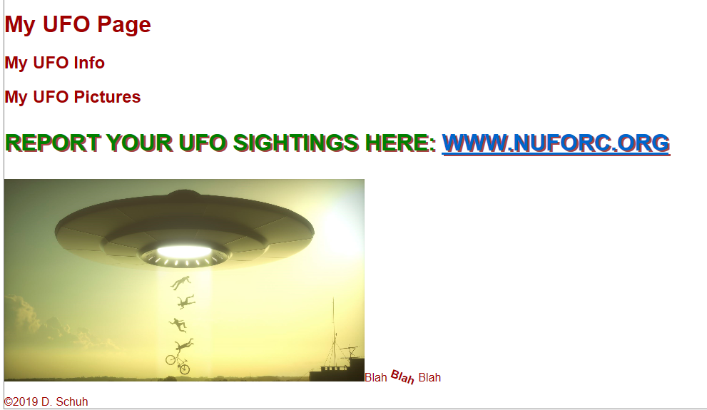

## Submission

Submit your GitHub URL to the corresponding MyCourses dropbox.